Can Region Explain Differences in Health in England?

Abstract
Improvements in health in England have stopped or slowed in the last 15 years, and broader regional inequalities have been exacerbated. There is also significant evidence for geographical inequalities in health, both on regional and local levels, although this may be explained by small area deprivation. This study used cross sectional data from the Health Survey for England 2021 to test for regional differences in self-rated health and whether region could predict poor health when socioeconomic and demographic factors were controlled for. Significant regional differences were found, in line with those in the literature and the UK’s broader regional inequalities. Region was a weak predictor of poor health in participants, with most of the variation being explained by age and small area deprivation. Region may be an underlying factor in understanding the wider determinants of health, as greater effort is made to understand the interaction between more proximate factors in causing poor health over the life course.

Background and Context
Since 2010, the number of years people in England can expect to be healthy during their lives has stopped increasing, the end of a century long trend (Marmot et al., 2020). Improvements in life expectancy (Office for National Statistics, 2025) and mortality rates have also slowed significantly in this time (Public Health England, 2018c). If health is to be taken as a socioeconomic barometer, and the health of the population has stopped improving, this suggests that society has stopped improving too (Case & Kraftman, 2022; Marmot et al., 2020).
This may reflect a difficult time for the UK, in which has experienced the financial crisis of 2008 and a period of austerity, which is thought to have adversely affected health outcomes (McKee et al., 2021). In this time, England’s significant and longstanding regional inequalities have also increased (Fai & Tomlinson, 2023). This may explain why geographical differences in health in England are particularly pronounced, and have worsened in recent years (Lally et al., 2025).
Literature Review
Geographical health inequalities can be analysed on small area, local authority and regional levels (Public Health England, 2018a), and may be due to geographical variation in the wider determinants of health. These are the social, economic and environmental conditions people live in (Public Health England, 2018b).
Using ONS data, Lally et al. (2025) found greater variation in health life expectancy (HLE) within regions than between them. The greatest difference in HLE between local authorities was 17.9 years, compared to 6.8 for regions. This is partly to be expected, as local authority data will average out across regions.
In their study of geographical inequalities, Marmot et al. (2020) found that the strongest relationship they found was between small area deprivation and life expectancy, with region a less significant factor. Wealthy areas in the North and South had similar levels of life expectancy, whereas deprived areas in the North had lower life expectancy. In other words, ‘region matters much more for people living in deprived areas’ (Marmot et al., 2020). Similarly, socioeconomic inequalities are generally larger at the local level and can underpin regional inequalities (Patias et al., 2021), suggesting that variation in the wider determinants of health may explain variation in health inequalities.
Demographic factors may also be implicated in regional differences in health. Differences by sex are generally small compared to geographical differences and are somewhat correlated (Marmot et al., 2020). Ethnicity is also an important factor in health, but there can be difficulties in studying it. Broad categories of ethnicity can hide variation between finer grained ethnic categories, and differences based on other factors, such as socioeconomic status (Public Health England, 2018a). Marmot et al. (2020) also found differences by ethnicity harder to identify, due to a lack of data, differences in 1st, 2nd and 3rd generation migrants and cultural differences in health reporting (Marmot et al., 2020).
What needs to be established is whether region is a significant factor in health when differences in smaller area deprivation are controlled for, and whether regions are a useful analytical unit.
Aim
To investigate whether the region people live in has a meaningful relationship with their health in England.
Objectives
To examine regional differences in self-rated health.
To test whether regional differences in self-rated health are statistically significant.
To test whether region can predict poor health when controlling for other factors.
Research Questions
RQ1: Are differences in self-rated health between regions statistically significant?
RQ2: Can participants’ region of residence predict poor health?
Methodology
2.1 Dataset and Variable Selection
Health Survey of England (HSE) 2021 dataset was chosen as it provides data on the whole of England for all age groups.

Table 2.1: Variable Summary
Variable Name | Variable Label | Measure | Type of Variable | Outcome | Categories
GENHELF | Self assessed general health | Health | Categorical - Ordinal | Dependent | 1(very good), 2 (good), 3 (fair), 4 (bad), 5 (very bad),
Binary_GENHELF | Self assessed general health | Health | Binary | Dependent | 0 (Good), 1 (Poor)
GOR1 | Government Office Region | Region | Categorical - Nominal | Independent | North East, North West, Yorkshire and the Humber, East of England, East Midlands, West Midlands, South West, South East, London
URBAN14B | Rurality of dwelling unit (urban/rural) | Urban/Rural | Binary | Independent | Urban OR Town/ Fringe/ Village, hamlet and isolated dwellings
QIMD19 | Quintiles of IMD score 2019 | Deprivation | Categorical - Ordinal | Independent | 1 (least deprived), 2, 3, 4, 5 (most deprived)
SEX | Sex | Sex | Binary | Independent | Male, Female
Age_Cat | Age Categorised - recoded from Age35g | Age | Categorical - Ordinal | Independent | 0-15, 16-29, 30-44, 45-59, 60-74,75+
ORIGIN2 | Grouped ethnic categories | Ethnicity | Categorical - Nominal | Independent | White, Black, Asian, Mixed/multiple ethnic background, Any other ethnic background

The dataset used consisted of the 8 variables in Table 2.1. Binary_GENHELF was recoded from GENHELF, all other variables were in the original dataset.
Self-assessed general health was selected as the dependent variable to provide a single measure of a person’s health. To represent region, Government Office Region (GOR1) was selected over Strategic Health Authority, as the latter were abolished by the Health and Social Care Act 2012. The other independent variables were chosen to represent social, economic and demographic factors that may influence health, including small area deprivation (QIMD19) which is well supported in the literature.
Table 2.2: Valid and Missing Values
Variable Name | Values | Missing
GENHELF | 7109 | 11*
GOR1 | 7120 | 0
URBAN14B | 7120 | 0
QIMD19 | 7120 | 0
SEX | 7120 | 0
Age_Cat | 7120 | 0
ORIGIN2 | 7079 | 41*
* 10 of the participants are invalid for both categories, meaning 42 participants were excluded from the data.

Participants with missing values were removed from the dataset. This reduced the dataset from 7120 observations to 7078 (Table 2.2). Of the 42 participants with missing values there was nothing particularly notable about their characteristics, and given it is a small sample size, it may be due to random variation. However, they were less likely to live in the least deprived quintiles.
Table 2.3: Age Categories
0-15
16-29
30-44
45-59
60-74
75+

The age categories (Table 2.3) were based on the stages of adult development in Halloran (2024). This ensured there were sufficient participants in each group and to reduce the number of categories, so the analysis was easier to interpret.
2.2 Analysis
Data analysis was conducted in SPSS.
Frequencies and sample sizes were reviewed for all variables.
RQ1: Are differences in self-rated health between regions statistically significant?
Exploratory analysis was conducted using weighted averages of self-rated health in each region. The formula for calculating weighted averages is below.
Weighted average = (Very Good * 5 + Good * 4 + Fair * 3 + Bad * 2 + Very Bad) / Region Total
To test whether there is a statistically significant relationship between region and self-rated health a chi-squared test for independence was used, because it tests the strength of association between two categorical variables (Pallant, 2020). Guidance in Pallant (2020) was used to conduct and interpret the test results.
RQ2: Can participants’ region of residence predict poor health?

Table 2.4: Binary Self Rated Health variable used for Logistic Regression
Binary_GENHELF (new) | GENHELF (original)
Good health | Very good
 | Good
Poor health | Fair
 | Bad
 | Very bad

To test whether region can predict poor health, an ordinal logistic regression would have been preferable (Pampel, 2021), given the dependent variable is ordinal with five categories. However, due to a low number of observations in the bad and very bad categories, the model indicated unreliability (Osborne, 2015). Therefore, self-rated health had to be recoded into two categories (Table 2.4). This meant a binary logistic regression could be run (Pallant, 2020).
The six independent variables were a mixture of ordinal and nominal (Table 2.1). To check for multicollinearity a linear regression had to be run to obtain the correlations, VIF and tolerance values (Pallant, 2020). SPSS automatically recoded the categorical variables into dummy variables.
When running the logistic regression, good health was used as the reference category. This meant the model was predicting poor health, which was the smaller category (Table 2.4), meaning the results are easier to interpret. The independent variables were also recoded so that the reference category contained the lowest number of participants in poor health (Pallant, 2020).

Results
3.1 Variable Frequencies
Table 3.1: Self assessed general health of Participants (n = 7078)
 | n | %
Very good | 2815 | 39.8
Good | 2692 | 38
Fair | 1149 | 16.2
Bad | 317 | 4.5
Very bad | 105 | 1.5
Total | 7078 | 100

A similar number of participants classify themselves as having very good (39.8%) or good (38%) health (Table 3.1). Relatively few participants are classified as having bad or very bad health, meaning regions had small sample sizes for these categories.
Table 3.2: Demographic Characteristics of Participants (n = 7078)
Sex of Participants | n | %
Male | 3292 | 46.5
Female | 3786 | 53.5
Total | 7078 | 100
Age Categories | n | %
0-15 | 1233 | 17.4
16-29 | 660 | 9.3
30-44 | 1289 | 18.2
45-59 | 1557 | 22
60-74 | 1566 | 22.1
75+ | 773 | 10.9
Total | 7078 | 100
Grouped Ethnic Categories | n | %
White | 6163 | 87.1
Black | 216 | 3.1
Asian | 471 | 6.7
Mixed/multiple ethnic background | 151 | 2.1
Any other ethnic group | 77 | 1.1
Total | 7078 | 100

Participants were more likely to be female (53.5%, Table 3.2), slightly higher than the population figure for England and Wales (51%) (HM Government, 2023). Four of the age categories had approximately 20% of participants, with 75+ and 16-29 having approximately 10%, no issues with sample sizes are anticipated though. Participants were more likely to be white (87.1%) compared to the population of England and Wales (81.7%) (Office for National Statistics, 2022). All other ethnic groups were underrepresented.
Table 3.3: Geographic Characteristics of Participants (n = 7078)
Government Office Region | n | %
North East | 607 | 8.6
North West | 828 | 11.7
Yorkshire and the Humber | 449 | 6.3
East Midlands | 580 | 8.2
West Midlands | 655 | 9.3
East of England | 943 | 13.3
London | 839 | 11.9
South East | 1378 | 19.5
South West | 799 | 11.3
Total | 7078 | 100
Rurality of dwelling unit | n | %
Urban | 5597 | 79.1
Town/ Fringe/ Village, hamlet and isolated dwellings | 1481 | 20.9
Total | 7078 | 100
Quintiles of IMD score 2019 | n | %
Least deprived | 1826 | 25.8
2 | 1635 | 23.1
3 | 1433 | 20.2
4 | 1148 | 16.2
Most deprived | 1036 | 14.6
Total | 7078 | 100

All regions have sufficient representation in the dataset (Table 3.3), although they are not entirely proportionate with population sizes for regions in 2021 (Office for National Statistics, 2021). Most participants live in urban areas (79.1%), similar to the population figure of 82.9% for 2019 (Government Office for Science, 2021). There are less participants from the more deprived quintiles, despite each quintile representing 20% of super output areas. This may mean people in deprived areas are underrepresented in the study.
RQ1: Are differences in self-rated health between regions statistically significant?
Table 3.4: Health Frequencies by Region
Region | Self-assessed general health
 | Very good | Good | Fair | Bad | Very bad | Total
North East | 191 | 248 | 119 | 37 | 12 | 607
North West | 317 | 276 | 163 | 55 | 17 | 828
Yorkshire and the Humber | 173 | 184 | 67 | 20 | 5 | 449
East Midlands | 234 | 219 | 94 | 26 | 7 | 580
West Midlands | 225 | 290 | 100 | 32 | 8 | 655
East of England | 368 | 366 | 162 | 32 | 15 | 943
London | 387 | 308 | 106 | 26 | 12 | 839
South East | 591 | 502 | 213 | 52 | 20 | 1378
South West | 329 | 299 | 125 | 37 | 9 | 799
Total | 2815 | 2692 | 1149 | 317 | 105 | 7078

With so few participants rating their health as very bad (Table 3.4), this could mean differences between regions in this category could result from random variation.
Table 3.5: Regions ranked by weighted average of self-assessed health
Region | Weighted Average | Very good | Good | Fair | Bad | Very bad
London | 4.23 | 46.1% | 36.7% | 12.6% | 3.1% | 1.4%
South East | 4.16 | 42.9% | 36.4% | 15.5% | 3.8% | 1.5%
South West | 4.13 | 41.2% | 37.4% | 15.6% | 4.6% | 1.1%
East Midlands | 4.12 | 40.3% | 37.8% | 16.2% | 4.5% | 1.2%
Yorkshire and the Humber | 4.11 | 38.5% | 41.0% | 14.9% | 4.5% | 1.1%
East of England | 4.10 | 39.0% | 38.8% | 17.2% | 3.4% | 1.6%
West Midlands | 4.06 | 34.4% | 44.3% | 15.3% | 4.9% | 1.2%
North West | 3.99 | 38.3% | 33.3% | 19.7% | 6.6% | 2.1%
North East | 3.94 | 31.5% | 40.9% | 19.6% | 6.1% | 2.0%
Conditional Formatting: Green = higher, Red = lower

The weighted averages in table 3.5 suggest that regional health inequalities show similar patterns to broader regional inequalities, with the North being worst off, and the South East and London performing best. The North East and North West stand out for having more participants in fair, bad and very bad health. This does not imply causation, but highlights patterns that justify further modelling.
Chi Square Test
Using the data in table 3.4, a Chi Square test for independence suggests that there are significant differences in self-rated health between regions (χ2 (32, n = 7078) = 87.584, p < 0.001, Cramer’s V = 0.056). However, a low value for Cramer’s V suggests the effect size is small.
All cells had an expected count greater than five, meaning assumptions concerning minimum expected cell frequency were met. However, small observed sample sizes for bad and very bad health may be unrepresentative of the true rates for each region.
Table 3.6: Adjusted Residuals for Chi Squared Test
Region | Self-assessed general health
 | Very good | Good | Fair | Bad | Very bad
North East | -4.4 | 1.5 | 2.4 | 2 | 1.1
North West | -0.9 | -3 | 2.9 | 3.2 | 1.4
Yorkshire and the Humber | -0.6 | 1.3 | -0.8 | 0 | -0.7
East Midlands | 0.3 | -0.1 | 0 | 0 | -0.6
West Midlands | -3 | 3.5 | -0.7 | 0.5 | -0.6
East of England | -0.5 | 0.5 | 0.8 | -1.7 | 0.3
London | 4 | -0.8 | -3 | -2.1 | -0.1
South East | 2.6 | -1.4 | -0.9 | -1.4 | -0.1
South West | 0.9 | -0.4 | -0.5 | 0.2 | -0.9
Bold where they indicate a significant difference

Table 3.6 shows the adjusted residuals, which can be used to identify where observed counts are significantly higher (>2) or lower (<-2) than expected (Pallant, 2020). Values for the North East and North West indicate worse health than expected, and values for London and the South East suggest they had more participants in good health than expected. However, London has more people in bad health than expected as well, suggesting inequalities within London not captured by regional categories.
RQ2 Can participants’ region of residence predict their self-rated health?
Table 3.7: Frequencies and Percentages for Binary_GENHELF
Region | Good Health |  | Poor Health
London | 695 | 82.8% | 144 | 17.2%
Yorkshire and the Humber | 357 | 79.5% | 92 | 20.5%
South East | 1093 | 79.3% | 285 | 20.7%
West Midlands | 515 | 78.6% | 140 | 21.4%
South West | 628 | 78.6% | 171 | 21.4%
East Midlands | 453 | 78.1% | 127 | 21.9%
East of England | 734 | 77.8% | 209 | 22.2%
North East | 439 | 72.3% | 168 | 27.7%
North West | 593 | 71.6% | 235 | 28.4%

Table 3.7 shows the regional variation in the binary measure of self-rated health used in the logistic regression. Again, the North East and North West are notably lower than the other regions.
Logistic Regression
Logistic Regression was used assess the relationship between six independent variables (region, small area deprivation, urban/rural, age, sex, ethnicity) and poor health.
Table 3.8 : Correlation Coefficients
 | Sex | Region | Urban/Rural | Age | QIMD | Ethnicity
Sex | 1 | -0.006 | 0.009 | -0.016 | -0.011 | 0.009
Region | -0.006 | 1 | -0.019 | 0.048 | 0.206 | -0.068
Urban/Rural | 0.009 | -0.019 | 1 | -0.079 | 0.098 | 0.104
Age | -0.016 | 0.048 | -0.079 | 1 | 0.043 | 0.192
QIMD | -0.011 | 0.206 | 0.098 | 0.043 | 1 | -0.069
Ethnicity | 0.009 | -0.068 | 0.104 | 0.192 | -0.069 | 1

The correlation coefficients suggest the independent variables are at most weakly correlated or unrelated, the highest coefficient being 0.206 for Region and QIMD (Table 3.8). This indicates that multicollinearity is unlikely to be a concern.

Table 3.9: Collinearity Statistics
IV | Tolerance | VIF
Age | 0.946 | 1.057
Region | 0.951 | 1.052
Ethnicity | 0.937 | 1.067
QIMD | 0.939 | 1.064
Urban/Rural | 0.966 | 1.035
Sex | 0.999 | 1.001

The collinearity statistics also indicate that multicollinearity is low (Table 3.9). Tolerance values below 0.1 and VIF values above 10 would be a concern (Pallant, 2020).
The full model containing all predictors was statistically significant, χ2(32, N = 7078) = 832.479, p < 0.001), suggesting it can successfully differentiate between participants in good and poor health, with an overall classification frequency of 78.5%. However, it only classified 10.8% of participants with poor health correctly, indicating that the model had limited ability to predict poor health cases.

Table 3.10: Logistic Regression Results (Dependent Variable = Self-rated Health)
Variable Name (RC = reference category) | Sig. | Exp(B) | 95% C.I.for EXP(B)
 |  |  | Lower | Upper
Age Classification (RC= 0-15) | <.001
16-29 | <.001 | 2.915 | 2.065 | 4.116
30-44 | <.001 | 3.482 | 2.575 | 4.709
45-59 | <.001 | 6.288 | 4.72 | 8.378
60-74 | <.001 | 10.117 | 7.613 | 13.446
75+ | <.001 | 18.04 | 13.342 | 24.393
Region (RC = London) | 0.014
Yorkshire and the Humber | 0.379 | 0.867 | 0.632 | 1.191
South East | 0.267 | 1.148 | 0.9 | 1.464
West Midlands | 0.61 | 0.93 | 0.704 | 1.229
South West | 0.622 | 1.071 | 0.816 | 1.406
East Midlands | 0.36 | 1.144 | 0.858 | 1.525
East of England | 0.214 | 1.18 | 0.909 | 1.531
North East | 0.222 | 1.192 | 0.899 | 1.58
North West | 0.006 | 1.434 | 1.11 | 1.853
Ethnicity (RC = White) | 0.634
Black | 0.882 | 0.972 | 0.672 | 1.408
Any other ethnic group | 0.36 | 1.335 | 0.719 | 2.48
Asian | 0.326 | 0.869 | 0.657 | 1.15
Mixed/multiple ethnic background | 0.411 | 0.792 | 0.455 | 1.38
Sex (RC = Male) | 0.449 | 1.047 | 0.929 | 1.181
Urban/Rural (RC = urban) | 0.021 | 1.203 | 1.029 | 1.408
QIMD (RC = Least deprived) | <.001
QIMD 4 | 0.276 | 1.108 | 0.921 | 1.331
QIMD 3 | <.001 | 1.52 | 1.264 | 1.828
QIMD 2 | <.001 | 2.065 | 1.706 | 2.499
QIMD - Most Deprived | <.001 | 2.724 | 2.228 | 3.33

The binary logistic regression found a number of significant relationships (Table 3.10). Region had a significant relationship with poor health (p = 0.014), however it was only for participants living in the North West (p = 0.006), which had significantly higher odds of poor health compared with London. Age classification had a significant relationship with poor health (p < 0.001) and was the most powerful predictor, with self-rated health declining considerably with age. As expected, small area deprivation (QIMD) also had a significant relationship with poor health (p < 0.001), with the likelihood of poor health increasing with deprivation level. Living in urban areas was also a significant predictor of poor health (p = 0.021). Sex (p = 0.449) and ethnicity (p = 0.634) were not significant predictors of poor health.

Table 3.11: Significant Predictors Ranked by Odds Ratio
Variable Name | Exp(B)
75+ | 18.04
60-74 | 10.117
45-59 | 6.288
30-44 | 3.482
16-29 | 2.915
QIMD - Most Deprived | 2.724
QIMD 2 | 2.065
QIMD 3 | 1.52
North West | 1.434
Urban/Rural | 1.203

Table 3.11 shows the significant predictors ranked by odds ratio. Being 75+ was the most powerful predictor of poor health, followed by the remaining age categories in reverse order. Living in the most deprived areas was the next strongest predictor, followed by living the next two most deprived categories. Living in the North West was a weak predictor of poor health and living in an urban area the weakest.
Discussion
There are significant regional differences in health (RQ1), which appear to be related to broader regional inequalities. Results suggest that region is significant, but with a small effect size, in participants’ health outcomes (RQ2). It was a weaker predictor than small area deprivation as anticipated by the results of Lally et al. (2025) and Marmot et al. (2020). This suggests that regional differences may be underpinned by larger local differences in deprivation levels (Patias et al., 2021). The results from this study cannot be used to infer what the interactions between region and small area deprivation are, but evidence from Marmot et al. (2020) suggests that the relationship between the two may be more complex than modelled here.
Age was found to be the most powerful predictor of poor health, which is unsurprising, but it was important to control for a powerful factor when there may be differences in age distributions between regions. That other demographic factors were not significant is unsurprising based on previous research (Lally et al., 2025; Marmot et al., 2020). This does not mean there are no differences between demographics, but that they cannot be observed in the presence of covariates.
It is worth considering what the factor ‘region’ is that influences health, given it is likely some aspect of its economy, society or geography that can be measured directly through other variables. This is because regions do not have inherent properties like other variables do. Difference by region may be difference by historical social and economic development (Fai & Tomlinson, 2023), which manifests itself in other variables in the present day, such as the age structure of its population or deprivation levels.
There is good evidence for regional health inequalities in the literature (Lally et al., 2025; Marmot et al., 2020), corroborated by the results of this study. Regional health inequalities also appear to align with the UK’s broader regional inequalities (Fai & Tomlinson, 2023). Whether region matters in public health is not so clear. It may depend on whether the determinants of health are best addressed on a local or regional basis.
Cross-sectional analyses using geographic units may also impose a limit on the understanding that can be gained from them. Due to the use of single-level models and cross-sectional data in this study, causal inference is limited. Causality between health and socioeconomic circumstances also runs both ways (Case & Kraftman, 2022), meaning it can be hard to identify which is the root cause. A solution to this may be using a life course approach as suggested by Case and Kraftman (2022). This would mean the coevolution of health and other factors such as income, education and socioeconomic status can be studied, given each influences the other.
Conclusion
England has significant regional differences in health, that align with its broader regional inequalities. However, region is a weak predictor of poor health, with most of the variation explained by age and small area deprivation. The problem with using region as a factor is that it does not have any inherent qualities, instead representing the social, economic and demographic qualities of the area, which can be measured by directly through other variables. Its usefulness as a concept in public health is therefore unclear as a result. Attention must also turn upstream to broader economic and societal factors that may underlie the UK’s poor performance on health metrics in the last 15 years.
The study was limited by the distribution of cases in the self-rated health data, with most participants classified as having good or very good health. There are also issues with using multiple indices of deprivation, as they mean the interrelation of health and factors such as income, education and employment cannot be separated in analyses such as these. The cross-sectional nature of the model also limited casual inference.
Current studies can identify associations between factors and health, but causality is much harder to establish. Future studies may benefit from a life course approach, which would enable the study of the interaction and coevolution of factors. This has the potential to yield a much deeper understanding of how health inequalities form.
In order to make significant advances in understanding how health inequalities form, it would appear that the interactions between proximate factors need to better understood. In this context, region may be an underlying factor in health inequalities.

References
Case, A., & Kraftman, L. (2022). Health Inequalities. Institute for Fiscal Studies. https://ifs.org.uk/publications/health-inequalities
Department of Health and Social Care. (2025, July 30). 10 Year Health Plan for England: fit for the future. GOV.UK. Retrieved January 5, 2026, from https://www.gov.uk/government/publications/10-year-health-plan-for-england-fit-for-the-future
Fai, F. M., & Tomlinson, P. R. (2023). Levelling up or down? Addressing regional inequalities in the UK. Contemporary Social Science, 18(3–4), 285–297. https://doi.org/10.1080/21582041.2023.2282161
Government Office for Science. (2021, June 28). Trend Deck 2021: Urbanisation. GOV.UK. Retrieved February 5, 2026, from https://www.gov.uk/government/publications/trend-deck-2021-urbanisation/trend-deck-2021-urbanisation#englands-urban-population-is-growing-faster-than-the-rural-population
Halloran, E. C. (2024). Adult Development and Associated Health Risks. Journal of Patient-centered Research and Reviews, 11(1), 63–67. https://doi.org/10.17294/2330-0698.2050
HM Government. (2023, March 31). Male and female populations. GOV.UK Ethnicity Facts And Figures. https://www.ethnicity-facts-figures.service.gov.uk/uk-population-by-ethnicity/demographics/male-and-female-populations/latest/
Lally, C., Steel, L., & Stiebahl, S. (2025). Geographical differences in healthy life expectancy. Parliamentary Office of Science and Technology. https://doi.org/10.58248/PB67
Marmot, M., Allen, J., Boyce, T., Goldblatt, & Morrison, J. (2020). Health Equity in England: The Marmot Review 10 Years On. Institute of Health Equity.
McKee, M., Dunnell, K., Anderson, M., Brayne, C., Charlesworth, A., Johnston-Webber, C., Knapp, M., McGuire, A., Newton, J. N., Taylor, D., & Watt, R. G. (2021). The changing health needs of the UK population. The Lancet, 397(10288), 1979–1991. https://doi.org/10.1016/s0140-6736(21)00229-4
Office for National Statistics. (2021). Estimates of the population for the UK, England, Wales, Scotland, and Northern Ireland [Dataset].
Office for National Statistics. (2022, November 29). Ethnic group, England and Wales. Retrieved February 8, 2026, from https://www.ons.gov.uk/peoplepopulationandcommunity/culturalidentity/ethnicity/bulletins/ethnicgroupenglandandwales/census2021
Office for National Statistics. (2024). Healthy life expectancy in England and Wales: between 2011 to 2013 and 2021 to 2023. In ONS. Retrieved January 6, 2026, from https://www.ons.gov.uk/peoplepopulationandcommunity/healthandsocialcare/healthandlifeexpectancies/bulletins/healthstatelifeexpectanciesuk/between2011to2013and2021to2023#cite-this-statistical-bulletin
Office for National Statistics. (2025, December 10). National life tables – life expectancy in the UK. Retrieved February 4, 2026, from https://www.ons.gov.uk/peoplepopulationandcommunity/birthsdeathsandmarriages/lifeexpectancies/bulletins/nationallifetablesunitedkingdom/2022to2024
Osborne, J. W. (2015). Best practices in logistic regression. SAGE Publications, Inc. https://doi.org/10.4135/9781483399041
Pallant, J. (2020). SPSS Survival Manual: A Step by Step Guide to Data Analysis Using IBM SPSS.
Pampel, F. C. (2021). Logistic Regression: A Primer. SAGE Publications, Inc. https://doi.org/10.4135/9781071878729
Patias, N., Rowe, F., & Arribas‐Bel, D. (2021). Trajectories of neighbourhood inequality in Britain: Unpacking inter‐regional socioeconomic imbalances, 1971−2011. Geographical Journal, 188(2), 150–165. https://doi.org/10.1111/geoj.12420
Public Health England. (2018a). Local Action on Health Inequalities: Understanding and Reducing Ethnic Inequalities in Health. Institute of Health Equity. Retrieved February 4, 2026, from https://www.instituteofhealthequity.org/resources-reports/local-action-on-health-inequalities-understanding-and-reducing-ethnic-inequalities-in-health-/understanding-and-reducing-ethnic-inequalities-in-health.pdf
Public Health England. (2018b, September 10). Chapter 6: wider determinants of health. GOV.UK. Retrieved January 5, 2026, from https://www.gov.uk/government/publications/health-profile-for-england-2018/chapter-6-wider-determinants-of-health
Public Health England. (2018c). A review of recent trends in mortality in England. PHE publications. Retrieved February 4, 2026, from https://assets.publishing.service.gov.uk/government/uploads/system/uploads/attachment_data/file/827518/Recent_trends_in_mortality_in_England.pdf

Appendix A: Chi Squared Test
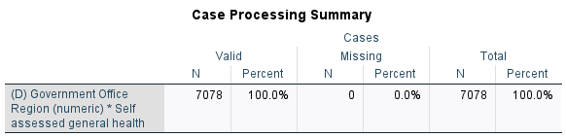
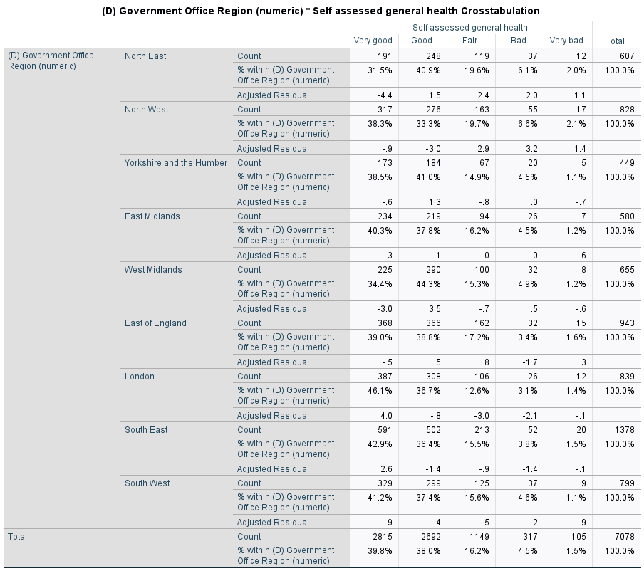

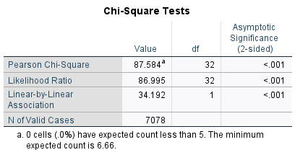
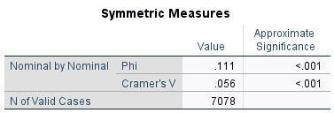

Appendix B: Logistic Regression Results
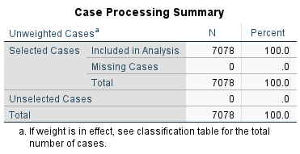
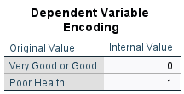
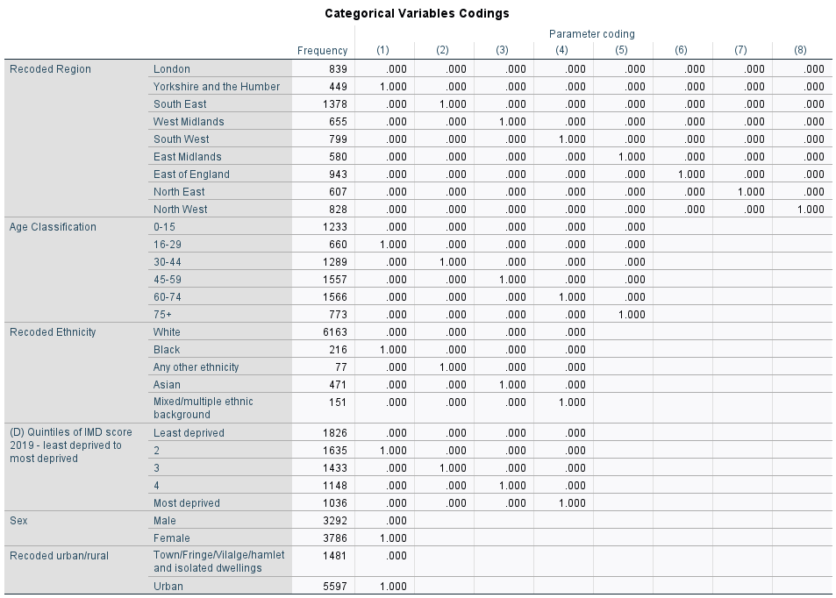
Block 0: Beginning Block
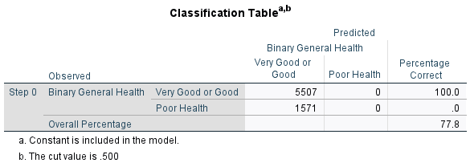
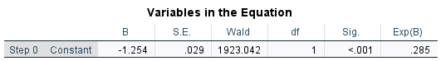
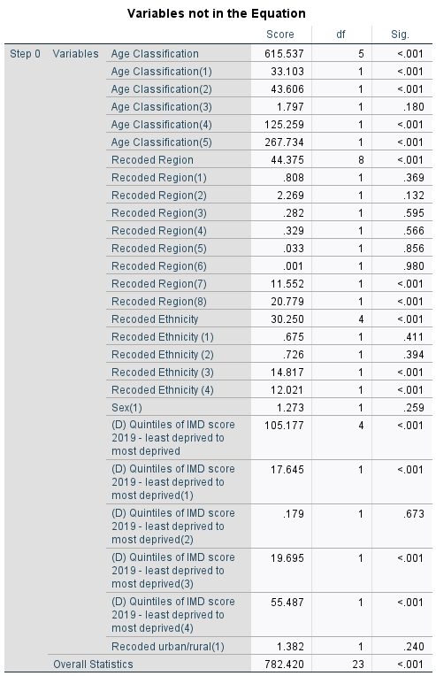
Block 1: Method = Enter
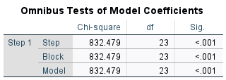
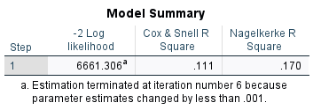
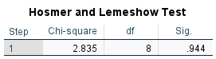
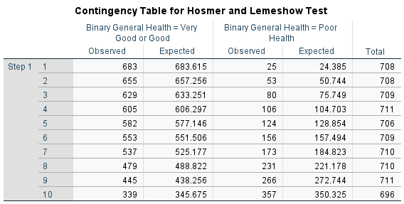
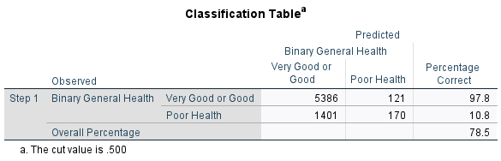
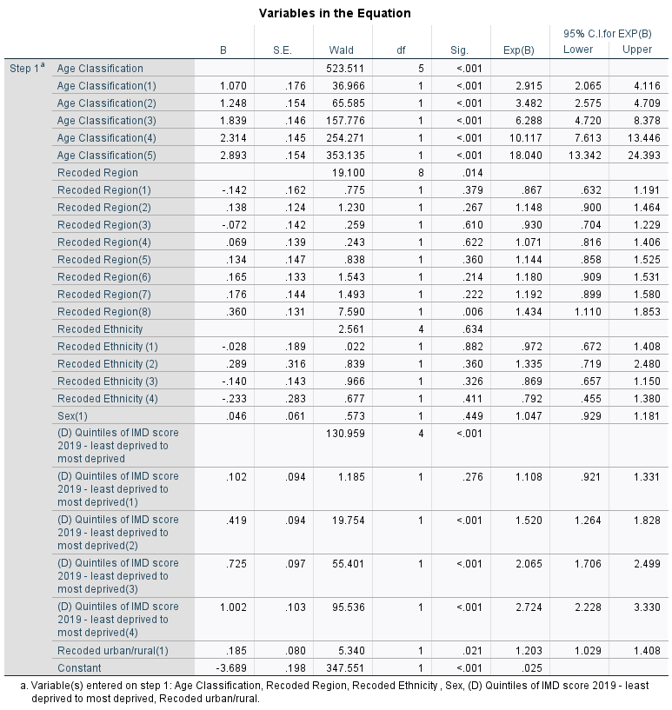

Step number: 1

Observed Groups and Predicted Probabilities

800 + +
I I
I I
F I I
R 600 + +
E I I
Q I I
U I V I
E 400 + V +
N I V I
C I V P I
Y I V VV PP P I
200 + V VVVP PVVP P P VP +
I VVVVV VVVVVVPVVVVVVPVVPVV PP I
I VVVVVVVVVVVVVVVVVVVVVVVVVVPVVVP PVPPPP PPP I
I VVVVVVVVVVVVVVVVVVVVVVVVVVVVVVVVVVVVVVVVVVPPPPPVP PP P I
Predicted ---------+---------+---------+---------+---------+---------+---------+---------+---------+----------
Prob: 0 .1 .2 .3 .4 .5 .6 .7 .8 .9 1
Group: VVVVVVVVVVVVVVVVVVVVVVVVVVVVVVVVVVVVVVVVVVVVVVVVVVPPPPPPPPPPPPPPPPPPPPPPPPPPPPPPPPPPPPPPPPPPPPPPPPPP

Predicted Probability is of Membership for Poor Health
The Cut Value is .50
Symbols: V - Very Good or Good
P - Poor Health
Each Symbol Represents 50 Cases.

